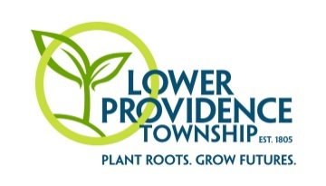
Come join the fun at the 32nd Annual Community Fall Festival!

Lower Providence Township’s Fall Festival is a popular family oriented community event. The average attendance exceeds 8,000 people of all ages each year. The event features include hayrides, pumpkin patch, food vendors, music, inflatables, carnival games, petting zoo, pony rides, touch-a-truck, business courtyard, crafters and more!
Consider being part of this wonderful community event. Spaces are limited so get your registration in early!
Lower Providence Township’s
“Community Fall Festival”
is an AWARD-WINNING event!!!
The 25th Annual Community Fall Festival won a Pennsylvania Recreation and Parks Society “Excellence in Programming” Award for Special Events with attendance over 2,500. The Lower Providence Township Parks and Recreation Department was recognized for the event at the 2013 Annual Pennsylvania Recreation and Park Society State Conference in Hershey, PA.
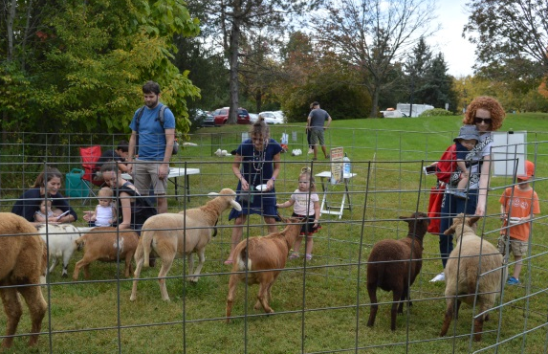

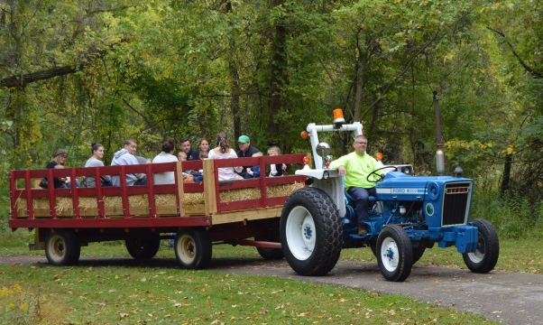

Please return all forms and payment by Friday, September 20, 2019:
Lower Providence Parks & Recreation
100 Parklane Drive, Eagleville, PA 19403

If you have any questions regarding the 2019 Fall Festival event, please contact:
Jane C. Delaney - Parks & Recreation Director
jdelaney@lowerprovidence.org
or
Karen M. Hegedus - Recreation Superintendent
khegedus@lowerprovidence.org
32nd ANNUAL COMMUNITY FALL FESTIVAL
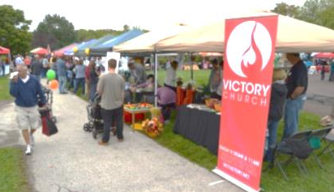
Saturday, October 5, 2019
(Rain Date: Sunday, October 6, 2019)
11:00 AM - 4:00 PM
Eagleville Park/Township Complex
Business Courtyard, Food Vendor & Crafter – 2019 Registration Form
Participation Levels

Business Courtyard* $115.00
(Includes 1 table and 1 chair under cover and on the
macadam. Business Courtyard attendees are listed in the event day brochure. Spaces are limited. This area sells out!
____________________________________________

Vendors/Crafters* $60.00
(A 10x10 space will be provided for you to sell your goods/crafts. You will need to provide your own table and tent. Space is limited.)
____________________________________________

Non-Profit/Tax Exempt Organizations* $30.00
(A 10x10 space will be provided. You will need to provide your own table and tent. Space is limited.)
_________________________________________________

Food Vendors* $150.00
(A 20x20 space will be provided. Must provide a current copy COI with LPT as additional insured with application and payment. If you would like to request a use of a generator, there is an extra $75.00 fee. (Limited Availability). This area sells out!
_________________________________________________

*EARLY REGISTRATION SAVINGS
if registered before July 1, 2019

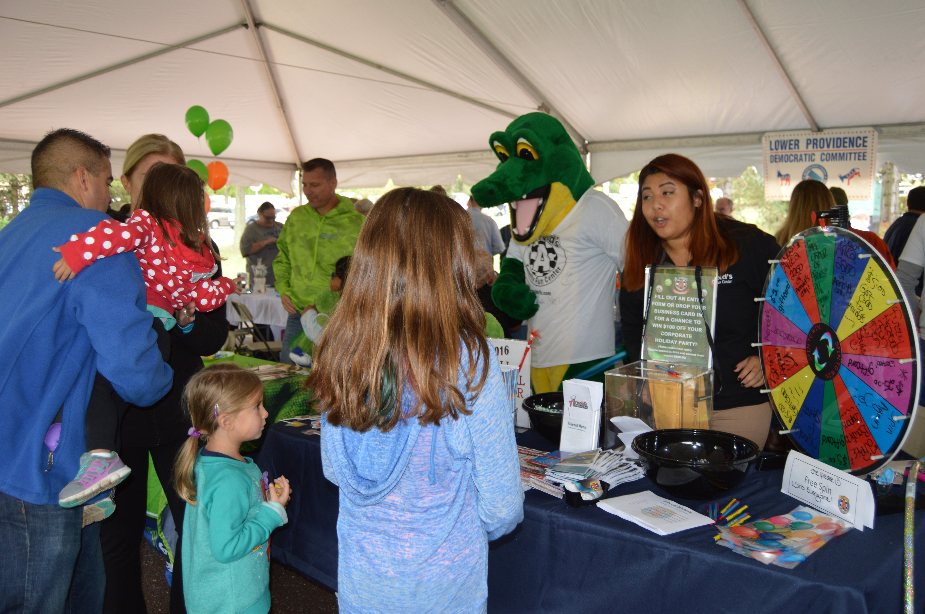
PLEASE COMPLETE AND RETURN WITH PAYMENT TO ADDRESS ABOVE.
Contact Name:
Company Name:
Address:
City, State, Zip:
Phone Number:
Email:

2019 COMMUNITY FALL FESTIVAL FEES (Please select one):
☐ Business Courtyard - $115.00 ($100.00 ERS)
☐ Crafter/Vendor - $60.00 ($50.00 ERS)
☐ Non-Profit Organization - $30.00 ($25.00 ERS)
☐ Food Vendor - $150.00 ($125.00 ERS)
☐ EXTRA Food Vendor Generator - $75.00

TOTAL DUE:

Payments can be made with cash, check or credit card. Please make checks payable to “Lower Providence Township”. Registration form and payment must be received by the Lower Providence Parks and Recreation office by Friday, September 20, 2019.

